Automation in Production Engineering
EML 4535C / EIN 6905
Class Periods: 2 days a week: 2hr lecture + 2hrs lab
Monday 9:35am – 11:35am, +Lab Time TBD (scheduled by group)
Credits: 3
Locations:
Lecture: MAE-C Room 010
Lab: MAE-C Room 010A / 002
Academic Term: Spring 2026

Instructor:
Dr. Katie Basinger-Ellis
Email Address: katie.basinger@ufl.edu
Office Phone: (352) 294-7730
Office Hours: TBD

Teaching Assistants/Peer Mentors/Supervised Teaching Students:
Isabel Stalcup (Lead TA) | isabel.stalcup@ufl.edu
Oliver Tumbel | olivertumbel@ufl.edu
Trevor Bendik | t.bendik@ufl.edu
Connor Ellis | ellisconnor@ufl.edu
Zack Walters | z.walters@ufl.edu
Cedric Gomez | cedricgomez@ufl.edu

Course Description
Students will learn how to design for and program parts using CNC machining. Students will be able to design a part to meet specifications using Fusion 360, program the code for machining (Computer Aided Manufacturing), and operate a CNC machine to make the part. This course includes 2 hours of lecture, and 2 hours of lab time each week. Lab times are individual to the lab team and will have an instructor present.

Course Pre-Requisites / Co-Requisites
Due to the low course enrollment size, Drs. Basinger-Ellis and Niemi will be selecting a cohort of students from applicants.
MAE Students: EML2023, a grade of A- or better in EML2322L, 4EG classification
ISE Students: CAD with Solidworks or Fusion360 (no exceptions), co-req EIN4451 or EIN4360

Course Objectives
- Understand and apply fundamentals of component design for subtractive and additive manufacturing with a focus on multi-axis CNC manufacturing
- Be able to select work holding and determine manufacturing datums for designed parts.
- Apply tooling/tool/toolpath selection and determine cutting parameters to program CNC machines
- Learn the fundamentals of operation for 3, 4, and 5-axis CNC machines
- Understand the basics of estimating production times and arranging schedules
- Summarize additive manufacturing methods and their comparability with traditional manufacturing

Materials and Supply Fees
All materials, supplies, and tooling are provided through funding from the IACMI – The Composites Institute and a generous donation from Autodesk Inc.

Relation to Program Outcomes (ABET):

Outcome | Coverage*
- An ability to identify, formulate, and solve complex engineering problems by applying principles of engineering, science, and mathematics | Medium
- An ability to apply engineering design to produce solutions that meet specified needs with consideration of public health, safety, and welfare, as well as global, cultural, social, environmental, and economic factors | High
- An ability to communicate effectively with a range of audiences
- An ability to recognize ethical and professional responsibilities in engineering situations and make informed judgments, which must consider the impact of engineering solutions in global, economic, environmental, and societal contexts
- An ability to function effectively on a team whose members together provide leadership, create a collaborative and inclusive environment, establish goals, plan tasks, and meet objectives | High
- An ability to develop and conduct appropriate experimentation, analyze and interpret data, and use engineering judgment to draw conclusions
- An ability to acquire and apply new knowledge as needed, using appropriate learning strategies | Medium
*Coverage is given as high, medium, or low. An empty box indicates that this outcome is not covered or assessed in the course.

Required Textbooks and Software
- Autodesk Fusion360 will be the primary CAD/CAM software used. Fusion360 is free for students with a “.edu” email address. It is compatible on Mac or PC and has a web-browser version.
- Microsoft Teams will be used as the primary communication tool for this course. Use of GroupMe or text messaging is highly discouraged.

Recommended Materials
- Cutting Tool Applications by George Schneider Jr., CMfgE (available for free via download)
- Machinery’s Handbook

Course Schedule
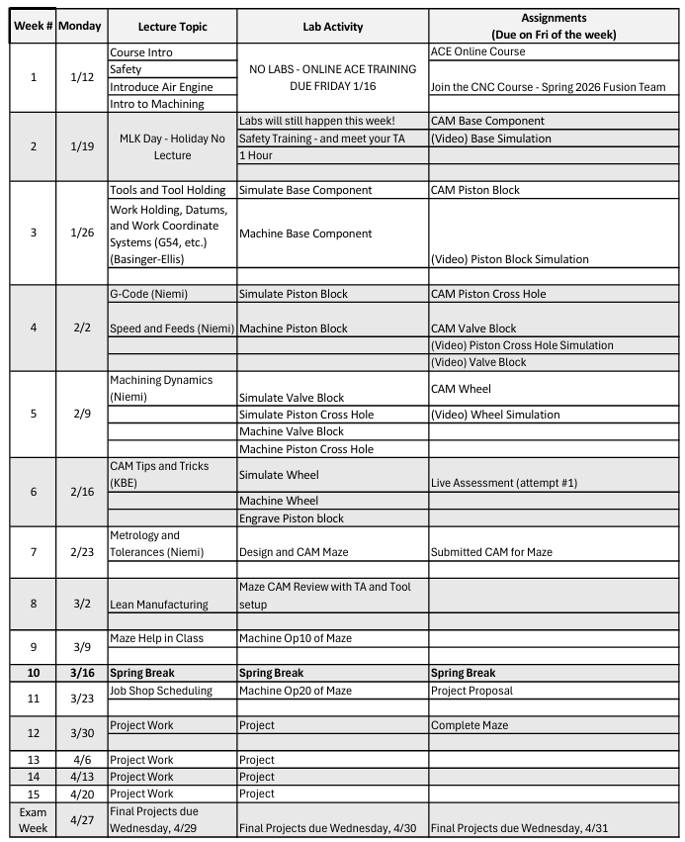
*Schedule subject to change during semester. Any modification will be announced in class and on Canvas.

Attendance Policy, Class Expectations, and Make-Up Policy
Attendance for lecture and lab sections is required. Students are expected to have all necessary CAD/CAM work completed prior to their arranged lab period. There will not be time in labs for anything more than a brief review of safety and operational parameters.

Do not use your cell phones as anything other than a camera or calculator when in lab. Cell phones are a major distraction and inhibit safe operation of the equipment.

If you are ill, or have a university approved excused absence, please bring it to the attention of the course instructors in a timely manner so we can schedule a suitable make-up period.
Excused absences must be consistent with university policies in the undergraduate catalog (https://catalog.ufl.edu/ugrad/current/regulations/info/attendance.aspx) and require appropriate documentation.

Evaluation of Grades
Assignment | Total Points | Percentage of Final Grade | Notes
Online ACE Certification | 100 | 5% | This is required to stay in the class and due on the last day of drop/add.
Air Engine + CAM | 100 | 25% | Five components; 20 pts each
Quizzes, HW, In-Class Assignments. | 100 | 25%
Live Assessment | 50 | 12.5% | Freedom!
Maze | 50 | 12.5%
Project 1 | 100 | 20% | Individual or group

Grading Policy
A: 93-100 A-: 90-92.99
B+: 88-89.99 B: 83-87.99 B-: 80-82.99
C+: 78-79.99 C: 73-77.99 C-: 70-72.99
D+: 68-69.99 D: 63-67.99 D-: 60-62.99
E: 0-59.99
More information on UF grading policy may be found at: https://catalog.ufl.edu/ugrad/current/regulations/info/grades.aspx

For specific University Policies regarding Gator Evals, Honesty Policy, In-Class Recording, Academic Resources, and Health & Wellness Resources please see: https://syllabus.ufl.edu/syllabus-policy/uf-syllabus-policy-links/

